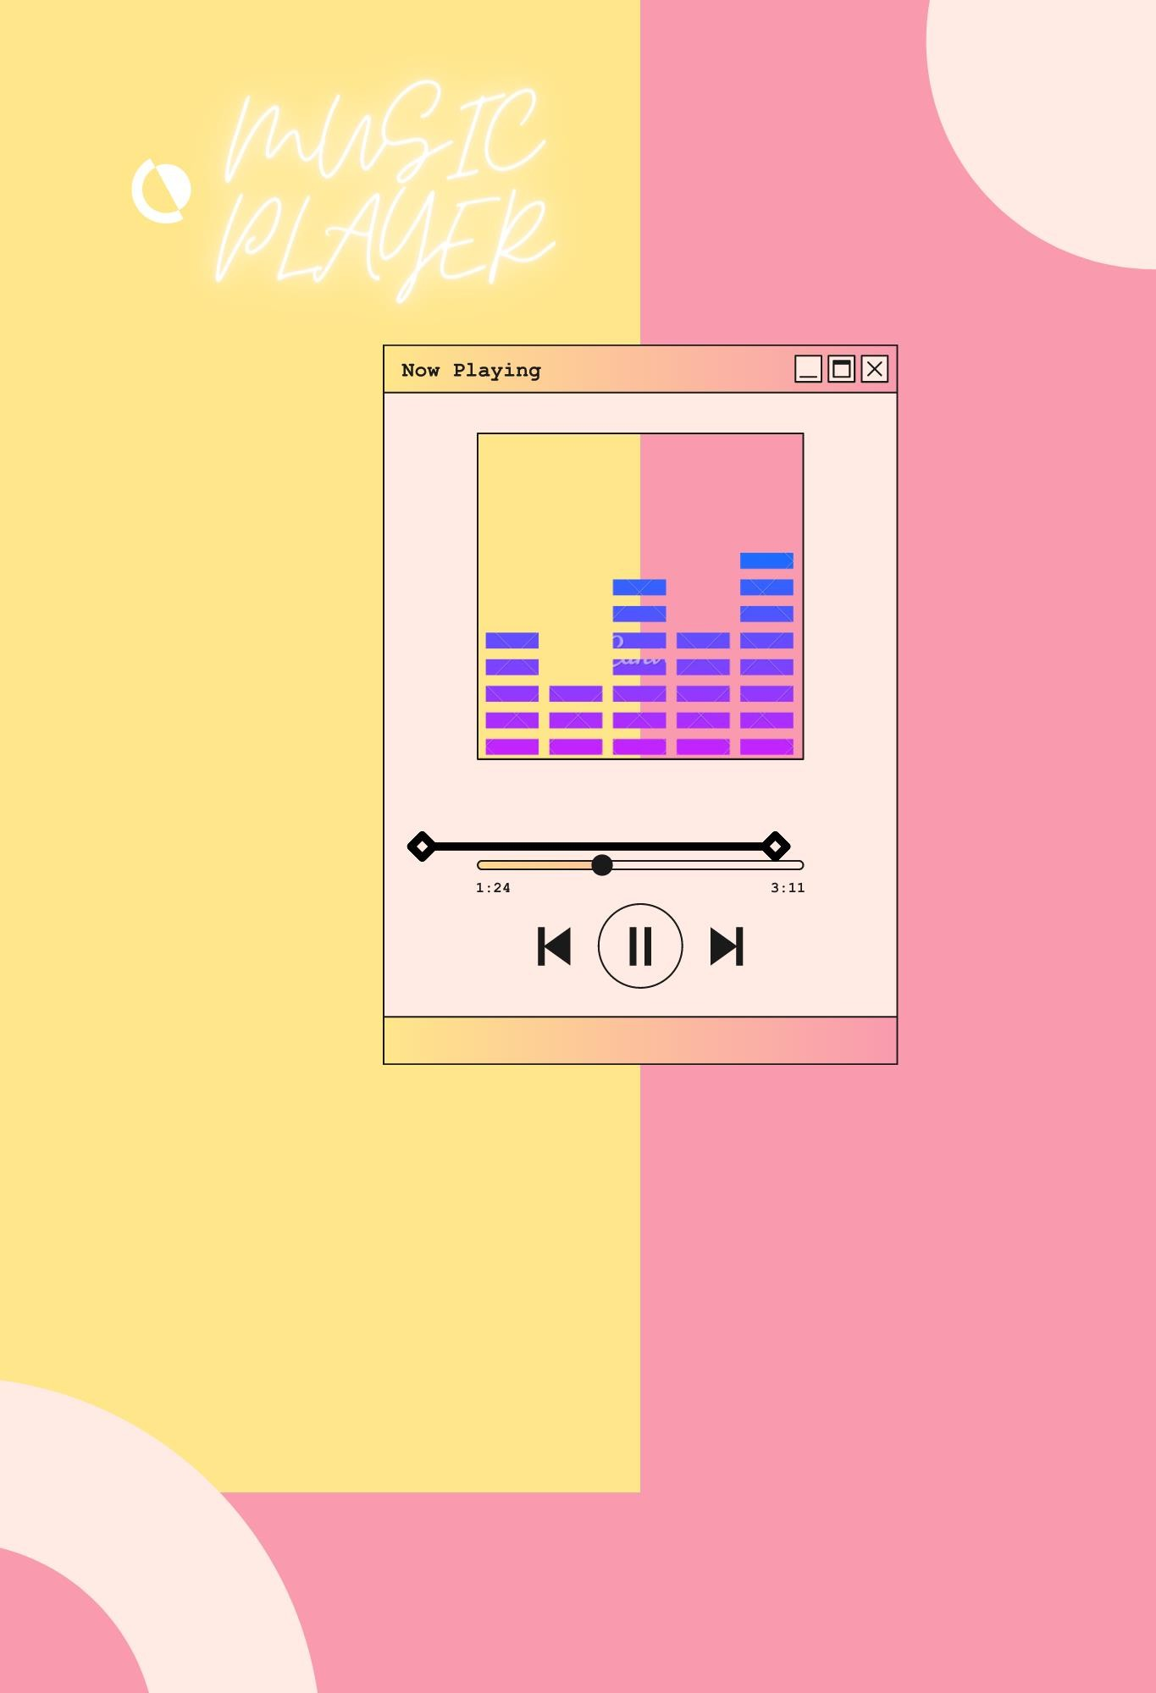

# Proposed by:

* **M. Zulqarnain (89)**
* **Malik Zohaib Altaf (79)**
* **Eeshah Qamar (66)**

**Submitted to:**

**Sir Waqas Ahmed**

Introduction:

Music is one of the best ways to relieve pressure in stressful modern society life. The purpose of this project is to develop a player which can play the mainstream of songs. We will be creating a music player with a clean user interface that can be used to play music in the browser. We will start by creating the HTML layout first that defines the structure of the player, make it look good by styling using CSS and then write the player logic for all the functionality in Java code. The backstage function module stores music file data. There are no corresponding songs for the first time, users need to add songs to play therefore user needs to click the add song button to add the first song in the playlist. Firstly, we will create the name of the playlist then we will have two menu options:

* Create the playlist
* Add song
* Song name
* Artist name
* Song duration
* Remove song
* Display playlist
* Play playlist:
* Play next song
* Play previous song
* Play same song
* Exit player
* Exit Music player

Problem Statement

Can not listen to online music if u don’t have stable internet connection.

Our playlist of songs is handled manually so there could be error or interruption in sound quality and video quality.

Opportunity Statement

The website is built for audience interaction

The website will enable a visitor to register.

1. For new visitor : **SIGN UP**
2. For regular visitor : **SIGN IN**

**Characteristics**:

* Web based using HTML, CSS
* Language java
* Data structures Double Linked List AND Circular Linked List
* Database Connectivity
* Design patterns: Facade, Decorator, Singleton, Factory.
* The design will be updated based on any changes required during coding stage to maintain the traceability of the system.

|  |  |
| --- | --- |
| **Name** | Functionality |
| Zulqarnain | JAVA Code  HTML, CSS (frontend)  Database Connectivity  Documentation |
| Zohaib |
| Eeshah |